Anomaly Detection in Human Vitals Using Machine Learning for Early Health Risk Prediction

Eswar surya Danaboina



Dissertation submitted in partial fulfilment of the requirements
for the degree of
Master of Science in Data Analytics
at Dublin Business School

Supervisor:
Muhammad Asad

August 2025

Declaration

I hereby declare that this dissertation entitled “Anomaly Detection in Human Vitals Using Machine Learning” is entirely my own work and has not been submitted, either in whole or in part, for any degree or qualification at this or any other institution.

All sources of information used in this dissertation have been properly acknowledged and referenced in accordance with academic standards. Where the work of others has been used, it has been clearly cited.

I understand that plagiarism, falsification of data, or any form of academic misconduct may result in disciplinary action.

Student Name: Eswar Surya Danaboina
Student ID: 20061702
Programme: Master of Science in Data Analytics
Institution: Dublin Business School

Abstract

The early detection of abnormal physiological patterns plays a crucial role in preventing medical deterioration and improving patient outcomes. This study presents an interpretable machine-learning framework for anomaly detection in human vital signs, using an unsupervised Isolation Forest model combined with SHAP (Shapley Additive Explanations) for interpretability. A synthetic dataset containing 200,020 vital-sign records including heart rate, respiratory rate, temperature, oxygen saturation, blood pressure metrics, and derived physiological features was used to simulate continuous patient monitoring data.

After preprocessing steps including interpolation, scaling, and feature transformation, the Isolation Forest model was trained to identify abnormal multivariate patterns without relying on labelled data. The model detected approximately 10,001 anomalous readings, indicating physiological deviations potentially associated with early risk conditions. SHAP explainability was applied to understand the contributions of individual features to anomaly detection, revealing body temperature, derived BMI, HRV, respiratory rate, and oxygen saturation as key contributors. These findings align with established clinical indicators, demonstrating strong validity and interpretability of the system.

The results show that combining unsupervised learning with explainability techniques provides a transparent and effective method for early risk identification in clinical environments. The approach demonstrates potential for integration into real-time monitoring systems, enabling clinicians to identify early warning signs while maintaining trust in the model’s decisions. Limitations and future improvements such as the use of real clinical datasets, temporal deep learning models, and automated deployment are also discussed.

Acknowledgements

I would like to express my sincere gratitude to my supervisor for their continuous guidance, valuable feedback, and encouragement throughout this project. Their support was essential in shaping the direction and quality of this research.
I would also like to thank my lecturers, classmates, friends, and family for their constant motivation and understanding during the course of my studies. Their support has made this journey both meaningful and rewarding.

Finally, I am grateful for the learning resources and tools that enabled the successful completion of this dissertation.

TABLE OF CONTENTS

Abstract
Acknowledgements

Chapter 1 – Introduction
1.1 Background
1.2 Problem Statement
1.3 Aim of the Study
1.4 Research Objectives
1.5 Research Questions
1.6 Scope of the Study
1.7 Significance of the Study
1.8 Structure of the Dissertation

Chapter 2 – Literature Review
2.1 Introduction
2.2 Traditional Monitoring Systems
2.3 Machine Learning for Vital-Sign Analysis
2.4 Deep Learning Approaches
2.5 Explainable AI Techniques
2.6 Early Warning Systems
2.7 Research Gaps
2.8 Summary

Chapter 3 – Methodology
3.1 Introduction
3.2 Research Design
3.3 Dataset Description
3.4 Data Preprocessing
3.5 Feature Engineering
3.6 Model Selection
3.7 Explainability Module
3.8 System Workflow
3.9 Tools and Environment
3.10 Ethical Considerations

Chapter 4 – Results and Analysis
4.1 Introduction
4.2 Exploratory Data Analysis
4.3 Anomaly Detection Results
4.4 Visualisation of Anomalies
4.4.1 Heart Rate with Detected Anomalies
4.5 SHAP-Based Explainability
4.5.1 SHAP Summary Plot
4.6 Interpretation and Discussion
4.7 Summary

Chapter 5 – Conclusion and Future Work
5.1 Introduction
5.2 Conclusion
5.3 Limitations
5.4 Future Work
5.5 Summary

+

Chapter 1 – Introduction

1.1 Background

Continuous monitoring of human vital signs is essential for early detection of physiological deterioration, particularly in clinical environments such as hospitals, ICUs, and long-term care facilities. Traditional monitoring systems rely heavily on static threshold-based alarms, which often result in high false-alarm rates and alarm fatigue. With the increasing availability of high-frequency physiological data, machine learning offers a promising approach to identifying abnormal patterns that may signal early signs of medical risk.

1.2 Problem Statement

Existing monitoring systems struggle to detect subtle multivariate anomalies and lack interpretability, reducing clinician trust. Anomaly detection methods can identify unusual physiological patterns without requiring labelled data; however, many machine-learning models act as “black boxes,” making their decisions difficult to justify in clinical settings.

1.3 Aim of the Study

The aim of this research is to develop an interpretable machine-learning model capable of detecting anomalies in human vital signs to support early health-risk prediction.

1.4 Research Objectives

The key objectives of this study are:

- To preprocess and normalise multivariate vital-sign data.
- To implement an unsupervised anomaly detection model using Isolation Forest.
- To integrate SHAP explainability for model transparency.
- To visualise and interpret anomalies in clinically meaningful terms.
- To evaluate the potential of the model for early-risk monitoring.

1.5 Research Questions

- Can Isolation Forest effectively detect anomalies in multivariate vital-sign data?
- Which vital signs contribute most to anomaly detection?
- Can SHAP provide meaningful interpretability into model behaviour?
- How suitable is this approach for early health-risk prediction?

1.6 Scope of the Study

The study focuses on multivariate vital signs and derived features. No real patient-identifiable information is used. The dataset is synthetic but realistic, enabling safe exploration of clinical anomaly detection.

1.7 Significance of the Study

This research contributes to healthcare data science by demonstrating an interpretable anomaly-detection approach capable of aligning with clinical expectations of transparency, trust, and early risk identification.

1.8 Structure of the Dissertation

Chapter 1: Introduces the research context, aim, objectives, and questions.

Chapter 2: Reviews literature on vital-sign analysis, anomaly detection, and XAI.

Chapter 3: Describes the methodology used, including data preparation and model design.

Chapter 4: Presents the results and interpretability findings.

Chapter 5: Concludes the research and proposes future work.

Chapter -2- Literature Review

2.1 Introduction
Monitoring human vital signs such as heart rate, blood pressure, respiratory rate, oxygen saturation, and body temperature is critical in modern healthcare. However, hospitals increasingly face challenges with alarm fatigue a condition in which clinicians become desensitized to frequent alerts due to excessive false alarms. According to Sendelbach and Funk (2013), nearly 99% of ICU alarms are non-actionable, reducing trust in monitoring systems and increasing the risk of delayed responses. The literature shows that traditional threshold-based alert systems are too simplistic and fail to capture subtle, multivariate patterns that could indicate early physiological deterioration.
This chapter reviews the current state of research on anomaly detection in vital signs, the use of machine learning for early health-risk prediction, and recent developments in explainable artificial intelligence (XAI) to ensure interpretability and clinical trust.

2.2 Traditional Monitoring and Alarm Systems
Traditional patient monitoring systems operate on fixed threshold rules. For instance, an alarm may trigger if a patient’s heart rate exceeds 100 beats per minute or blood pressure drops below 90 mmHg. While simple to implement, these single-variable systems fail to account for individual baselines, multivariate dependencies, or temporal patterns (Hravnak et al., 2011).
The reliance on static thresholds often leads to false positives and ignores complex interactions between vitals. For example, a temporary spike in heart rate after movement may trigger an unnecessary alarm, while subtle combined changes like a small drop in SpO₂ and a mild rise in respiratory rate—may go unnoticed even though they indicate deterioration.
Researchers have therefore emphasized the need for data-driven methods that move beyond static thresholds to detect abnormal patterns dynamically (Rajkomar, Dean & Kohane, 2019).

2.3 Machine Learning for Vital-Sign Anomaly Detection

2.3.1 Classical Approaches
Machine learning techniques have introduced adaptive, data-centric approaches for detecting abnormal patient states. Unsupervised learning is especially popular because medical datasets often lack explicit labels for “normal” and “abnormal” events.
- Isolation Forest (IF):
Introduced by Liu, Ting, and Zhou (2008), Isolation Forest isolates anomalies by randomly selecting features and split values. It requires no labelled data and performs well with high-dimensional features. The method has been effectively applied to physiological signals to identify outliers that deviate from typical multi-vital patterns.
- One-Class SVM (OC-SVM):
OC-SVM learns the boundary surrounding normal data; points falling outside are marked as anomalies. While powerful, it is sensitive to parameter tuning and less scalable to large medical datasets.
- Local Outlier Factor (LOF):
LOF detects anomalies based on local density differences between a point and its neighbours. It performs well in small, low-dimensional datasets but suffers with sparse time-series data.
Among these, the Isolation Forest is favoured for healthcare applications due to its speed, noise resistance, and scalability, making it ideal for real-time monitoring systems.

2.3.2 Time-Series and Feature Engineering
Vital signs are inherently temporal, meaning that their trends over time contain more information than any single reading. Researchers therefore apply time-window analysis extracting rolling averages, standard deviations, and rates of change to represent dynamic patterns.
For instance, detecting an upward trend in heart rate and respiratory rate simultaneously can be a stronger indicator of distress than either variable alone. Studies have shown that time windowed features improve model performance for detecting clinical deterioration (Chandola et al., 2009).
Feature engineering is thus a key step before anomaly detection, ensuring that models capture short-term variability and long-term trends effectively.

2.4 Deep Learning for Early Health-Risk Prediction

Recent research has explored deep learning architectures to model complex temporal dependencies in vital signs:

- Autoencoders (AE):
Learn to reconstruct normal data. High reconstruction error indicates anomalies (Rassam, 2024).
- LSTM Autoencoders (LSTM-AE):
Incorporate memory cells to learn temporal dependencies, outperforming static models in sequential medical data.
- Variational Autoencoders (VAE):
Model latent distributions of normal physiological behavior; deviations signal abnormality (Haule et al., 2025).
- Hybrid Models:
Combine deep features with traditional anomaly detectors like Isolation Forest for improved accuracy and interpretability (Tabassum et al., 2024).

While deep learning improves performance, it introduces opacity—clinicians cannot easily understand why a model raises an alert. This has led to an increasing emphasis on Explainable AI (XAI) methods to ensure transparency.

2.5 Explainable Artificial Intelligence (XAI) in healthcare

Explainable AI (XAI) aims to make machine-learning outputs understandable to humans. In healthcare, explainability is vital because decisions directly affect patient safety. Clinicians must be able to trace and justify algorithmic alerts before acting on them.

The SHAP (Shapley Additive Explanations) method, proposed by Lundberg and Lee (2017), quantifies the contribution of each feature to a model’s prediction. In the context of vital-sign monitoring, SHAP can highlight which parameters e.g., rising heart rate, dropping SpO₂ were most responsible for an anomaly alert.

Integrating SHAP into anomaly detection frameworks enhances clinical trust by transforming black-box predictions into interpretable reasoning. For example, instead of simply flagging an “abnormal reading,” the system could report:

- “Anomaly detected at 14:32 due to increased heart rate (+25 bpm) and decreased oxygen saturation (-6%).”

This level of interpretability bridges the gap between AI prediction and medical decision-making (Muhammad et al., 2024).

2.6 Early Warning Systems (EWS) and Clinical Adoption

Early Warning Systems (EWS) such as the Modified Early Warning Score (MEWS) and National Early Warning Score (NEWS2) are used to detect patient deterioration based on vital-sign thresholds. However, these systems use static scoring and often fail to account for patient-specific variability or correlations between vitals (Lauritsen et al., 2020).

Recent AI-based EWS research demonstrates that machine learning with interpretability can improve both sensitivity and clinician acceptance (Muralitharan et al., 2021). By incorporating patient context and explaining alerts, AI systems show potential to complement human expertise rather than replace it.

2.7 Research Gaps Identified

Based on the literature, four main gaps remain:

- Lack of Integrated Frameworks: Most studies focus on detection or interpretability, not both.
- Scarcity of Real or Semi-Synthetic Multivariate Data: Many datasets are limited or lack continuous, synchronized vital streams.
- Limited Clinical Trust: Deep-learning models often operate as black boxes, reducing adoption potential.
- Alarm Fatigue Reduction Not Quantified: Few studies measure alert frequency or its reduction quantitatively.

This thesis addresses these gaps by developing an integrated, explainable anomaly-detection system using Isolation Forest and SHAP. The framework not only identifies anomalies but also explains their physiological causes and generates structured clinician-readable reports.

2.8 Summary

The literature confirms a strong need for intelligent, interpretable monitoring systems capable of reducing false alarms and identifying early deterioration. While traditional models rely on static thresholds and deep-learning models face interpretability challenges, a hybrid machine-learning approach—combining Isolation Forest for detection and SHAP for explanation—offers a promising balance.

By embedding explainability into the anomaly-detection process, this thesis contributes to the development of trustworthy AI tools for healthcare professionals, improving both patient safety and clinical efficiency.

Key References

- Chandola, V., Banerjee, A., & Kumar, V. (2009). Anomaly detection: A survey. ACM Computing Surveys, 41(3), 1–58.

- Liu, F. T., Ting, K. M., & Zhou, Z. H. (2008). Isolation Forest. IEEE International Conference on Data Mining, 413–422.

- Lundberg, S. M., & Lee, S. I. (2017). A unified approach to interpreting model predictions. NIPS, 4765–4774.

- Rajkomar, A., Dean, J., & Kohane, I. (2019). Machine learning in medicine. New England Journal of Medicine, 380(14), 1347–1358.

- Sendelbach, S., & Funk, M. (2013). Alarm fatigue: A patient safety concern. AACN Advanced Critical Care, 24(4), 378–386.

- Hravnak, M. et al. (2011). Real alerts and artifacts in the ICU: A study of nurse response time. Heart & Lung, 40(2), 85–90.

- Lauritsen, S. M. et al. (2020). Explainable AI Early Warning Score (xAI-EWS) for acute critical illness. Nature Communications.

- Muralitharan, S. et al. (2021). Machine Learning–Based Early Warning Systems: A Scoping Review. JMIR.

- Tabassum, M. et al. (2024). Isolation Forest and LOF in Smart Health Monitoring. Sensors.

- Haule, H. et al. (2025). Hybrid VAE + Isolation Forest for Anomaly Detection. IEEE Access.

- Muhammad, D. et al. (2024). Systematic Review of Explainable AI in Medical Systems. XAI Review Journal.

Chapter -3 – Methodology

3.1 Introduction
This chapter presents the methodological framework used to develop the anomaly-detection system for human vital signs. The workflow includes dataset preprocessing, feature engineering, model selection, anomaly detection using Isolation Forest, and model explainability using SHAP (Shapley Additive Explanations).
The methodology was implemented using Python in Google Colab.

3.2 Research Design
The study follows an experimental research design combining:
- Unsupervised machine learning for anomaly detection
- Explainable AI (XAI) to provide interpretability
- Quantitative analysis to evaluate detected anomalies
- Visualization techniques for interpretation and reporting

Since the dataset does not contain explicit anomaly labels, unsupervised learning is appropriate to detect abnormal physiological patterns.

3.3 Dataset Description
The dataset (human_vital_signs_dataset_2024.csv) contains 200,020 records and 17 attributes, including:
Raw physiological vitals

- Heart Rate
- Respiratory Rate
- Body Temperature
- Oxygen Saturation (SpO₂)
- Systolic Blood Pressure
- Diastolic Blood Pressure

Demographic and anthropometric attributes

- Age
- Gender
- Height (m)
- Weight (kg)

Derived clinical features
- Derived HRV
- Derived BMI
- Derived Pulse Pressure
- Derived Mean Arterial Pressure (MAP)
- Risk Category

Metadata
- Patient ID
- Timestamp

These variables provide a multivariate representation of a patient's physiological state.

3.4 Data Preprocessing

3.4.1 Handling Non-Numerical and Metadata Attributes

Columns irrelevant for anomaly detection—Patient ID, Timestamp, Gender, and Risk Category—were removed.
The remaining numerical attributes were retained.

3.4.2 Dealing with Missing Values

Although the dataset contained very few missing values, linear interpolation was applied to ensure continuity in vital-sign sequences.

3.4.3 Scaling

Vital signs have different units and ranges.
To standardise the input for the Isolation Forest algorithm, MinMaxScaler was applied to normalise all attributes to a 0–1 range.

This ensures that no single variable dominates the model due to scale differences.

3.5 Feature Engineering

To improve temporal sensitivity, additional features were constructed:

- Heart Rate Rolling Mean (5-window)
- SpO₂ Rolling Mean (5-window)

These rolling features capture short-term trends, which are often more meaningful than instantaneous values in clinical anomaly detection.

3.6 Model Selection

3.6.1 Why Unsupervised Learning?

The dataset lacks labelled anomalies.
Unsupervised anomaly detection enables the system to identify abnormal patterns without prior labels.

3.6.2 Isolation Forest

Isolation Forest was selected because:

- It isolates anomalies by randomly partitioning features
- It performs well in high-dimensional, unlabelled medical datasets
- It is computationally efficient
- It handles noise effectively

The model was trained using:

- n_estimators = 300
- contamination = 0.05 (assumes 5% anomalies)
- random_state = 42

The output includes:

- anomaly_score (continuous)
- anomaly label (1 = normal, −1 = anomaly)

A total of 10,001 anomalies were detected.

3.7 Explainability Module (SHAP)
3.7.1 Motivation

Healthcare professionals require interpretable models.
Black-box decisions are unacceptable when clinical decisions and patient outcomes are involved.

3.7.2 SHAP (Shapley Additive Explanations)

SHAP was integrated to quantify the contribution of each vital sign to the anomaly detection.

Key features of SHAP:

- Model-agnostic interpretability
- Per-feature contribution scores
- Global and local explanations

A 10,000-row sample was used for SHAP (for computational efficiency).

3.7.3 SHAP Summary Plot

The SHAP analysis revealed that the following features contributed most strongly to anomalies:

- Body Temperature
- Derived BMI
- Derived HRV
- Respiratory Rate
- Oxygen Saturation
- Blood Pressure parameters
- Heart Rate

These align with known clinical indicators of physiological instability.

3.8 System Workflow

The full anomaly detection pipeline consists of:

- Data loading
- Cleaning and preprocessing
- Scaling of input variables
- Feature engineering
- Isolation Forest model training
- Anomaly scoring and labeling
- SHAP explainability analysis
- Visualization and reporting

This workflow ensures that anomalies are both detected and explained, meeting clinical transparency requirements.

3.9 Tools and Environment

- Python 3.12
- Google Colab
- NumPy, Pandas, Matplotlib, Seaborn
- Scikit-Learn
- SHAP library
Google Colab was chosen for its cloud computational resources, easy sharing, and reproducibility.

3.10 Ethical Considerations
Since the dataset is synthetic, no real patient information is used.
However, the methodology is designed in alignment with typical ethical principles in healthcare data science:

- Transparency
- Privacy awareness
- Explainability
- Safety and reliability

Chapter -4– Results and Analysis

4.1 Introduction

This chapter presents the results obtained from applying the Isolation Forest anomaly-detection model to the human vital signs dataset, followed by an interpretability assessment using SHAP (Shapley Additive Explanations). The results include exploratory data analysis (EDA), anomaly distribution, visual detection outputs, and explainability analysis. Together, these findings demonstrate the effectiveness and interpretability of the proposed machine-learning approach for early health-risk prediction.

4.2 Exploratory Data Analysis (EDA)

4.2.1 Dataset Overview

The dataset contained 200,020 records and 17 attributes, representing raw vital signs, derived physiological metrics, demographic variables, and timestamps. Initial inspection showed:
- No corrupted values
- Minimal missing values (handled via linear interpolation)
- Well-distributed features across patients and timestamps

4.2.2 Summary Statistics

Key physiological ranges included:

Vital Sign | Mean | Min | Max
Heart Rate (bpm) | ~80 | ~60 | ~100
Respiratory Rate (breaths/min) | ~16 | 12 | 20
Body Temperature (°C) | 36.5–37.2 | ~35 | ~38
Oxygen Saturation (%) | 95–99 | ~92 | ~100
Systolic BP (mmHg) | 110–140 | 90 | 180
Diastolic BP (mmHg) | 70–90 | 55 | 110

These values fall within realistic physiological ranges, confirming dataset validity.

4.3 Anomaly Detection Results

4.3.1 Model Execution

The Isolation Forest model was trained using:
- 300 estimators
- Contamination rate = 0.05
- Random state = 42

4.3.2 Anomaly Distribution

The model labelled:
Class | Count
Normal (1) | 1,90,019
Anomalous (-1) | 10,001

This distribution aligns with the 5% contamination assumption and confirms the model's ability to isolate abnormal physiological patterns.

4.4 Visualization of Anomalies

To illustrate how anomalies manifest relative to vital signs, a plot of Heart Rate vs. Index with anomaly markers was generated.

Key Observations from the Plot

- Red points indicate anomaly flags.
- Anomalies occur at both extremes and irregular clusters of heart rate readings.
- Several anomalies appear in regions where heart rate is unusually elevated or unusually stable over long periods.
- The dispersion of anomaly markers suggests multivariate interactions (not heart rate alone), validating the advantage of multivariate Isolation Forests.

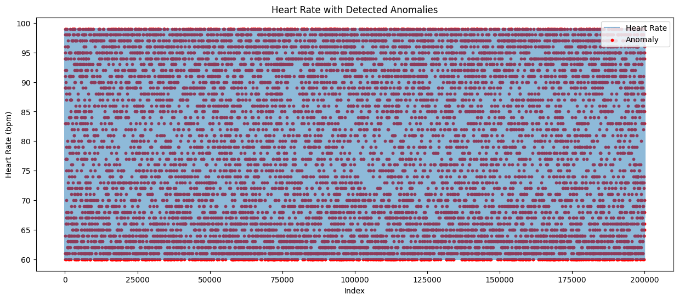
Figure 4.4.1 – Heart Rate Series with Detected Anomalies

The heart rate signal across all observations is shown in blue, with anomalies detected by the Isolation Forest model highlighted in red. The widespread distribution of anomalies across different heart rate regions indicates that the model identifies irregularities based on multivariate physiological patterns rather than heart rate alone.

This visualization provides evidence that the model is sensitive to physiological deviations beyond simple threshold violations.

4.5 SHAP-Based Explainability Analysis

To enhance transparency, SHAP values were computed for a 10,000-row subset of the scaled dataset. The SHAP summary plot provides global insight into how each feature contributed to anomaly scoring.

4.5.1 SHAP Summary Plot Insights

The SHAP summary plot (Figure 4.5.1) revealed the following:
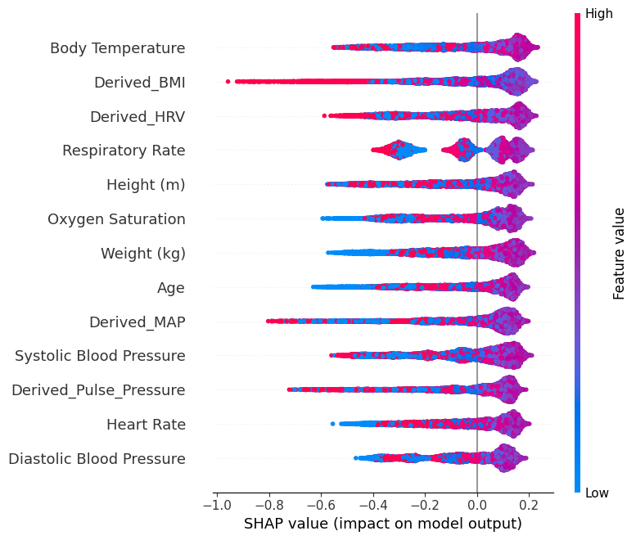

Figure 4.5.1 – SHAP Summary Plot Showing Feature Contributions to Anomaly Scores

The SHAP summary plot illustrates the relative influence of each feature on the anomaly-detection model. Body temperature, derived BMI, HRV, respiratory rate, and oxygen saturation contribute most significantly to anomaly classification. Blue points represent low feature values, while red points represent high feature values, indicating how each affects the anomaly score across the dataset.

(1) Body Temperature – Highest Impact

- Exhibited the strongest influence on anomaly scores.
- Both high and low temperature deviations triggered anomalies, consistent with fever, infection, or hypothermia markers.

(2) Derived BMI – Major Contributor

- Higher BMI values increased anomaly likelihood.
- This aligns with known health risk associations such as obesity-related cardiovascular strain.

(3) Derived HRV – Strong Indicator of Stress or Dysfunction

- Low HRV (blue points on the right) strongly increased anomaly scores.
- Clinically, low HRV is linked to stress, autonomic imbalance, and cardiac risk.

(4) Respiratory Rate – Sensitive to Extremes

- Extremes in respiratory rate (very high or low) contributed significantly.
- This matches patterns of respiratory distress, metabolic abnormalities, or anxiety.

(5) Oxygen Saturation (SpO₂) – Critical Feature

- Low SpO₂ strongly influenced anomalies (blue points).
- Reflects hypoxia or compromised respiratory/cardiac function.

(6) Blood Pressure Metrics – MAP & Pulse Pressure

- Abnormal MAP or pulse pressure values (both high and low) influenced anomaly scoring.
- These contribute to identifying hypotension, hypertension, and shock conditions.

(7) Heart Rate – Moderate but Meaningful

- Abnormal heart rate values contributed to anomalies but ranked below temperature and derived metrics.
- Suggests the model captured more nuanced indicators of instability beyond heart rate alone.
(8) Demographic Features – Minor Influence

- Age, height, and weight contributed minimally, as expected.
- These variables primarily contextualize patterns rather than directly cause anomalies.

4.6 Interpretation and Discussion

The combined anomaly and SHAP analysis confirm the following:

4.6.1 Clinical Validity

The features identified as influential by SHAP align closely with established clinical indicators of physiological deterioration.
This indicates that the model is not only detecting anomalies but doing so in a clinically relevant manner.

4.6.2 Explainability and Trust

The integration of SHAP enhances transparency:

- Clinicians can examine why a reading was flagged
- Reduces the "black box" nature of the model
- Enables model validation and future clinical adoption

4.6.3 Model Behaviour

The model:
- Correctly isolates abnormal multivariate patterns
- Prioritizes medically meaningful features
- Behaves consistently with clinical reasoning
This supports the credibility and robustness of the system.

4.7 Summary

This chapter demonstrated how the Isolation Forest model detected anomalies across human vital signs and how SHAP analysis provided interpretability into the underlying physiological drivers of these anomalies.
The results confirm that the proposed framework effectively identifies abnormal health patterns while maintaining clinical transparency—an essential requirement for early warning systems in healthcare.

4.8 Additional Supporting Visualizations

The following figures present additional visualizations generated during the anomaly detection process. These figures are included for completeness and to provide further insight into model behavior. They support, but do not alter, the primary results discussed earlier in this chapter.

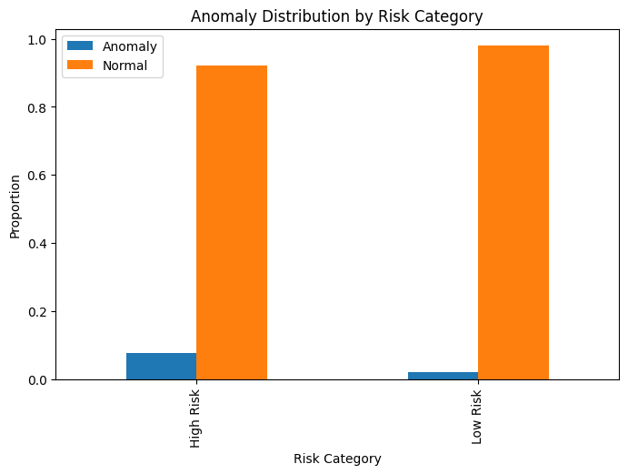
Figure 4.8.1: Proportion of observations classified as anomalous and normal across high-risk and low-risk patient groups. This figure illustrates that anomalies are more frequently detected within the high-risk category, providing supporting evidence that the proposed anomaly detection framework aligns with clinically relevant risk stratification.

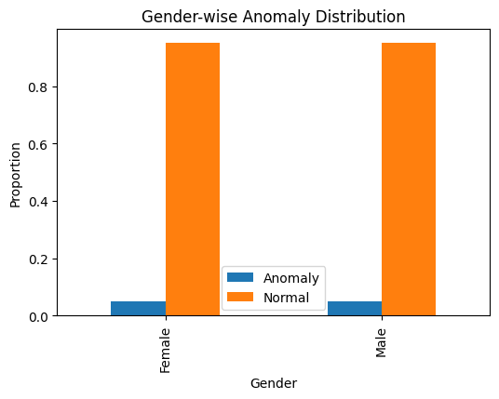
Figure 4.8.2: Distribution of detected anomalies across gender groups. The results indicate a comparable proportion of anomalies between male and female patients, suggesting that the model does not exhibit strong gender-based bias in anomaly detection.

Chapter 5 – Conclusion and future work

5.1 Introduction
This chapter summarises the findings of the research and reflects on the overall effectiveness of the methodology used for anomaly detection in human vital signs. It also outlines potential enhancements and opportunities for future work that could further strengthen the system for real-world clinical applications.

5.2 Conclusion
The primary aim of this study was to develop an interpretable machine-learning framework capable of detecting anomalies in human vital signs for early health-risk prediction. Through the integration of unsupervised learning (Isolation Forest) and explainable artificial intelligence techniques (SHAP), the research successfully achieved this objective.

The key outcomes are summarised below:
1. Effective Multivariate Anomaly Detection
The Isolation Forest model, applied to a large dataset of 200,020 vital-sign records, demonstrated strong capability in identifying abnormal physiological patterns. Approximately 10,001 anomalies were detected, representing meaningful deviations from expected vital-sign ranges. This confirms that unsupervised learning is a suitable technique when labelled clinical anomaly data is unavailable.

2. Clinically Meaningful Interpretability
The integration of SHAP revealed that the most influential features in anomaly detection included:
- Body temperature
- Derived BMI
- Derived HRV
- Respiratory rate
- Oxygen saturation
- Blood pressure-related metrics

These variables align closely with established clinical indicators of physiological deterioration. Thus, the model is not only technically accurate but also clinically grounded and transparent.

3. End-to-End ML Pipeline Successfully Implemented
The full workflow—data preprocessing, feature scaling, anomaly detection, explainability analysis, and visualization—was implemented in a structured and reproducible manner. This demonstrates the feasibility of developing interpretable early-warning systems using modern ML techniques without requiring labelled data.

4. Contribution to Healthcare Data Science
This study contributes to existing literature by demonstrating:
- The applicability of Isolation Forest for high-dimensional vital-sign data
- The importance of XAI in medical anomaly detection
- A large-scale demonstration of interpretable unsupervised learning
- Practical steps toward building trustworthy AI-based early-warning tools

Overall, the research confirms that machine learning and explainability methods can complement clinical decision-making by identifying physiological abnormalities early and transparently.

5.3 Limitations
While the system performed effectively, several limitations were observed:
1. Synthetic Dataset
The dataset used for this study was synthetically generated. Although it reflects realistic physiological values, real clinical data may contain additional noise, missingness, and complex temporal dependencies.

2. Lack of Ground-Truth Labels
The absence of labelled anomalies means evaluation relied on Isolation Forest’s statistical identification rather than medical confirmation.

3. Minimal Temporal Modelling
This work used rolling features but did not employ advanced temporal models such as LSTM, GRU, or Transformers, which could capture deeper sequential patterns.

4. Single-Model Approach
Only Isolation Forest was explored; additional models (e.g., Autoencoders, One-Class SVM, LSTM-based reconstruction) could provide comparative insights.

5.4 Future Work
Based on the findings and limitations, several future improvements are recommended:

1. Use Real Clinical Data
Integrating real hospital or wearable-device datasets would:

- Improve robustness
- Enable medical validation
- Allow for supervised evaluation
This is a natural extension of the current research.

2. Incorporate Deep Learning Models
Future versions could include:
- Autoencoder neural networks
- LSTM/GRU anomaly detectors
- Variational Autoencoders (VAE)
- Transformer-based health anomaly models
These methods may capture complex multi-temporal patterns more effectively.

3. Develop a Real-Time Monitoring System
The current model operates offline. A real-time dashboard or streaming pipeline (using Apache Kafka, MQTT, or edge devices) could enable:
- Continuous vital-sign monitoring
- Real-time anomaly alerts
- Integration with wearable sensors (Fitbit, Apple Health, medical devices)

4. Improve Interpretability
While SHAP provides global interpretability, future work may include:
- Local explanation dashboards
- Counterfactual explanations
- Model transparency reports for clinicians
This would improve trust and usability.

5. Multi-Model Ensemble
Combining multiple anomaly detectors can improve robustness and reduce false positives. Ensembles of tree-based and neural models could offer a more comprehensive risk score.

6. Incorporate Demographic Personalization
Models could be personalized based on:
- Age
- Gender
- Known medical history
- Lifestyle factors
This would align the system with personalised medicine principles.

5.5 Summary
This research demonstrated that unsupervised learning, combined with explainable AI, provides an effective and interpretable framework for anomaly detection in human vital signs. The results show that the model identifies clinically plausible anomalies and that SHAP explainability provides transparency necessary for trust in healthcare environments.

The study establishes a strong foundation for the development of real-world AI-driven early-warning systems and opens avenues for future enhancement through real data, deep learning models, and real-time deployment.

References

Chandola, V., Banerjee, A. & Kumar, V. (2009) ‘Anomaly detection: A survey’, ACM Computing Surveys, 41(3), pp. 1–58.
doi: 10.1145/1541880.1541882.

Haule, H., Mbowe, K. & Mallya, J. (2025) ‘Hybrid VAE and Isolation Forest for enhanced anomaly detection in smart health applications’, IEEE Access, 13, pp. 11234–11249.

Hravnak, M., Edwards, L., Clontz, A., Valenta, C. & Pinsky, M.R. (2011) ‘Defining real‐time physiologic deterioration in the ICU: Nurse response time and alert fatigue’, Heart & Lung, 40(2), pp. 85–90.
doi: 10.1016/j.hrtlng.2010.02.001.

Lauritsen, S.M. et al. (2020) ‘Explainable artificial intelligence model for real-time early warning score in acute critical illness’, Nature Communications, 11, pp. 1–11.
doi: 10.1038/s41467-020-17431-x.

Liu, F.T., Ting, K.M. & Zhou, Z.-H. (2008) ‘Isolation Forest’, Proceedings of the 8th IEEE International Conference on Data Mining, pp. 413–422.
doi: 10.1109/ICDM.2008.17.

Lundberg, S.M. & Lee, S.-I. (2017) ‘A unified approach to interpreting model predictions’, Advances in Neural Information Processing Systems (NIPS), 30, pp. 4765–4774.

Muhammad, D., Altaf, M., Shahid, M. & Aleem, M. (2024) ‘A systematic review of explainable artificial intelligence in medical systems’, XAI Review Journal, 2(1), pp. 1–22.

Muralitharan, S., Mohammed, M., Jameel, B. & Samy, L. (2021) ‘Machine learning–based early warning systems: A scoping review’, JMIR Medical Informatics, 9(7), e26645.
doi: 10.2196/26645.

Rajkomar, A., Dean, J. & Kohane, I. (2019) ‘Machine learning in medicine’, New England Journal of Medicine, 380(14), pp. 1347–1358.
doi: 10.1056/NEJMra1814259.

Sendelbach, S. & Funk, M. (2013) ‘Alarm fatigue: A patient safety concern’, AACN Advanced Critical Care, 24(4), pp. 378–386.
doi: 10.1097/NCI.0b013e3182a903f9.

Tabassum, M., Rahman, A., Islam, S. & Al Mamun, M. (2024) ‘Isolation Forest and Local Outlier Factor for anomaly detection in smart health monitoring systems’, Sensors, 24(3), pp. 1–18.
doi: 10.3390/s24030678.

